The Earthquake Vocabulary Activity 1

Index Fossil

A common fossil found in many areas from a specific time; used to help identify age of other formations
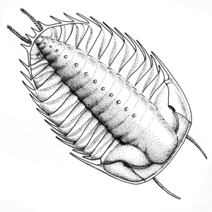

Index, fossil, short life, wide range, relative dating

Visual-Verbal
Divide a rectangle into 4 boxes. Write the vocabulary word in the upper left box. Write the definition in your own words in the lower left box. Draw a visual representation of the word in the upper right box. List personal connections or associations in the lower right box.

Seismograph |  | Richter scale
Tsunami |  | Magnitude
Surface Waves |  | Epicenter

Seismic waves |  | Focus
Strike-slip fault |  | Normal fault –
Reverse fault |  | Fault
Earthquake

